setwd("D:/998.Python/Data-Analysis-Portfolio/project_06_total_happiness_R")

지금 생각 중인건
랜덤포레스트 등이랑
BIC 등 실현.

지금 데이터 다시 둘러보면서 해야 할 것같아
결측, 미싱밸류, NA 등. 그다음 다시 해야돼
BIC랑 랜덤포레스트, 부스팅인가 마지막에 한거 이 정도 해서 주면 될 듯.
기존에 했던 그 내용에 그냥 모델만 바꿔서 주는 게 더 편할 듯.

데이터 구조(총 10개 열) : year(2015~2023) 수기입력, country, region, happiness_score, gdp_per_capita, social_support, healthy_life_expectancy, freedom_to_make_life_choices, generosity, perceptions_of_corruption

1. 랜덤 포레스트 등 시행

# package install & load
install.packages("randomForest")
library(randomForest)

# data processing
df <- read.csv("data/full_data.csv")
df$year <- as.integer(df$year)
df$country <- as.factor(df$country)
df$region <- as.factor(df$region)
key_vars <- c(
"happiness_score",
"gdp_per_capita",
"social_support",
"healthy_life_expectancy",
"freedom_to_make_life_choices",
"generosity",
"perceptions_of_corruption"
)

# 결측값이 있는 행 제거
df_clean <- na.omit(df)
df_clean$perceptions_of_corruption[df_clean$perceptions_of_corruption == "N/A"] <- NA
df_clean <- df_clean[complete.cases(df_clean), ]
df_clean$perceptions_of_corruption <- as.numeric(df_clean$perceptions_of_corruption)

# 2015~2022년 데이터를 훈련 데이터로, 2023년 데이터를 테스트 데이터로 분리
train_data <- df_clean[df_clean$year <= 2022, ]
test_data <- df_clean[df_clean$year == 2023, ]

# 데이터 구조 확인
str(df_clean)

# 랜덤 포레스트 모델 훈련
rf_model <- randomForest(happiness_score ~ gdp_per_capita + social_support +
healthy_life_expectancy + freedom_to_make_life_choices +
generosity + perceptions_of_corruption,
data = train_data, ntree = 100)

# 모델 요약
print(rf_model)

# 2023년 데이터에 대해 예측
predictions <- predict(rf_model, newdata = test_data)

# 예측 결과 확인
comparison <- data.frame(Actual = test_data$happiness_score, Predicted = predictions)
print(comparison)

# R^2 계산
rmse_rf <- sqrt(mean((predictions - test_data$happiness_score)^2))
rsq_rf <- 1 - (sum((predictions - test_data$happiness_score)^2) / sum((test_data$happiness_score - mean(test_data$happiness_score))^2))

cat("Random Forest RMSE:", rmse_rf, "\n")
cat("Random Forest R^2:", rsq_rf, "\n")

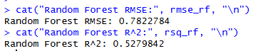

# making plots!!!!!!
predictions <- predict(rf_model, newdata = test_data)

# Actual vs Predicted plot
plot(
test_data$happiness_score, predictions,
xlab = "Actual Happiness Score (2023)",
ylab = "Predicted Happiness Score (2023)",
main = "Prediction Model: Actual vs Predicted (2023)",
pch = 19,
col = rgb(0, 0.4, 0.8, 0.6)
)

# y = x 회귀선 추가
abline(0, 1, col = "red", lwd = 2)

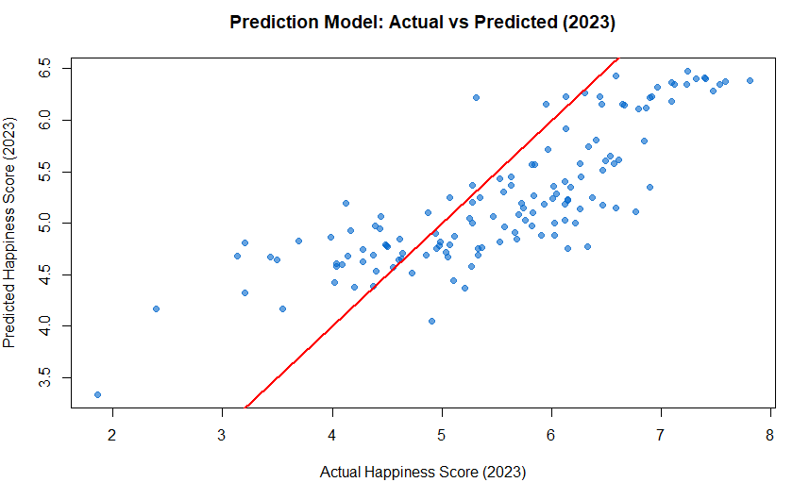

# plot for GDP

# 훈련 데이터에서 랜덤 포레스트 예측값 구하기
train_predictions <- predict(rf_model, newdata = train_data)

# Happiness vs GDP plot
plot(
train_data$happiness_score, train_data$gdp_per_capita,
xlab = "Happiness Score (Train 2015–2022)",
ylab = "GDP per Capita",
main = "Distribution of the Training Model: Happiness vs GDP",
pch = 19,
col = rgb(0, 0.4, 0.8, 0.6)
)

# 회귀선 추가 (선형 회귀 모델)
abline(lm(gdp_per_capita ~ happiness_score, data = train_data), col = "red", lwd = 2)

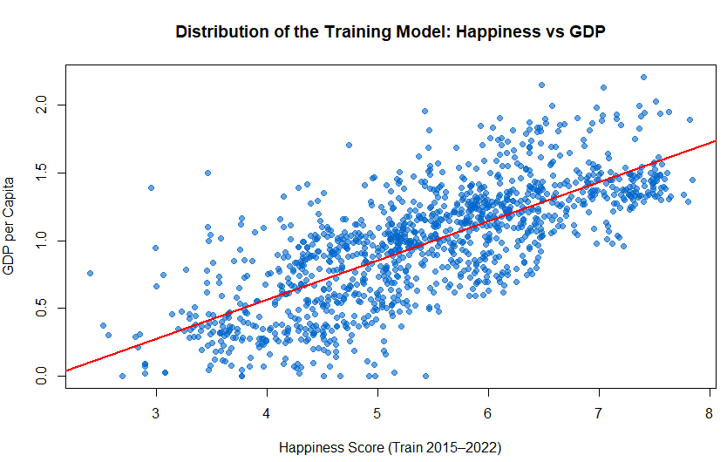

#### heatmap
# 필요한 패키지 불러오기
library(ggplot2)
library(reshape2)

# 랜덤포레스트 모델에서 사용한 변수들 지정 (예시)
vars <- c(
"happiness_score",
"gdp_per_capita",
"social_support",
"healthy_life_expectancy",
"freedom_to_make_life_choices",
"generosity",
"perceptions_of_corruption"
)

# 상관 행렬 계산 (NA 값을 제외하고 계산)
cor_mat <- cor(df_clean[, vars], use = "complete.obs")

# 상관 행렬을 데이터프레임으로 변환 (히트맵에 사용할 수 있도록)
cor_df <- melt(cor_mat)
names(cor_df) <- c("Var1", "Var2", "value")

# 히트맵 그리기
ggplot(cor_df, aes(x = Var2, y = Var1, fill = value)) +
geom_tile() + # 타일을 사용하여 색을 채움
geom_text(aes(label = round(value, 2)), size = 3) + # 상관계수 값을 타일에 표시
scale_fill_gradient2(
low = "white",
high = "darkred",
mid = "orange",
midpoint = 0,
limits = c(-1, 1)
) + # 색상 조정
labs(
title = "Correlation Heatmap of Happiness and Explanatory Variables",
x = "",
y = ""
) + # 제목 및 라벨
theme_minimal(base_size = 14) +
theme(
axis.text.x = element_text(angle = 45, hjust = 1) # x축 라벨 각도 설정
)

#draw- map
# rworldmap 패키지 설치
install.packages("rworldmap")

# rworldmap 패키지 로드
library(rworldmap)

# 2023년 예측값을 기반으로 한 데이터 준비
whr2023 <- df_clean[df_clean$year == 2023, ]

# 국가별 예측값을 맵에 결합
sPDF <- joinCountryData2Map(
whr2023,
joinCode = "NAME", # 국가 이름을 기준으로 결합
nameJoinColumn = "country" # 'country' 컬럼을 기준으로 매칭
)

# 맵을 그리기
par(mai = c(0, 0, 0.2, 0.4))
mapCountryData(
sPDF,
nameColumnToPlot = "happiness_score", # 'happiness_score' 컬럼을 맵에 표시
mapTitle = "Happiness Score Map 2023",
colourPalette = "heat", # 색상 팔레트 설정
catMethod = "pretty" # 색상 구간 설정
)

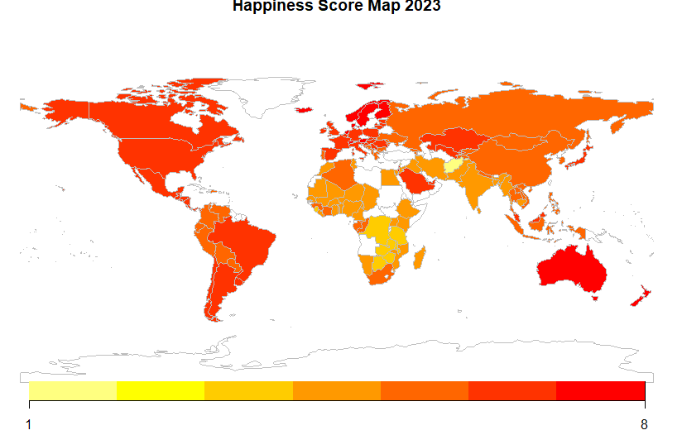

library(dplyr)
region_stats <- df_clean %>%
filter(year == 2023) %>%
group_by(region) %>%
summarise(
mean_happy = mean(happiness_score, na.rm = TRUE),
sd_happy = sd(happiness_score, na.rm = TRUE),
n = n(),
se_happy = sd_happy / sqrt(n)
) %>%
arrange(desc(mean_happy))
ggplot(region_stats, aes(x = reorder(region, mean_happy), y = mean_happy)) +
geom_col(fill = "orange") +
geom_errorbar(aes(ymin = mean_happy - se_happy,
ymax = mean_happy + se_happy),
width = 0.2) +
coord_flip() +
labs(
title = "Happiness Score for Different Regions (2023)",
x = "Region",
y = "Average Happiness Score"
) +
theme_minimal(base_size = 14)

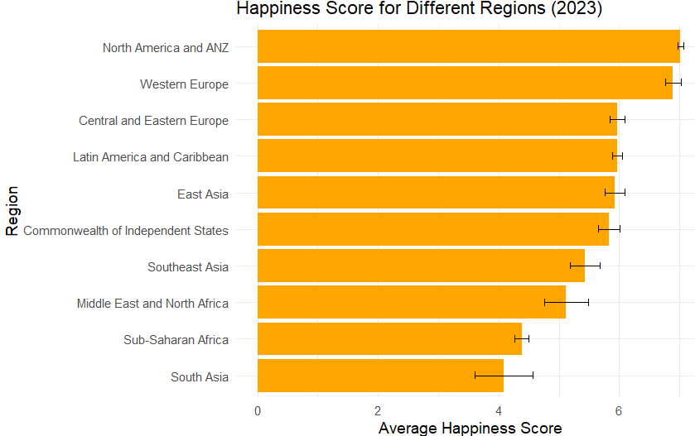

# cross-validation
# 교차 검증을 통한 랜덤 포레스트 모델 훈련
install.packages("caret")
library(caret)

# `tuneLength`로 자동으로 `mtry` 값을 조정
train_control <- trainControl(method = "cv", number = 10)

# `tuneLength`를 사용하여 자동으로 `mtry` 값 최적화
rf_model_cv <- train(
happiness_score ~ gdp_per_capita + social_support + healthy_life_expectancy +
freedom_to_make_life_choices + generosity + perceptions_of_corruption,
data = df_clean,
method = "rf",
trControl = train_control,
tuneGrid = data.frame(mtry = 1:6) # `mtry` 값을 1부터 6까지 제한
)
# 모델 출력
print(rf_model_cv)
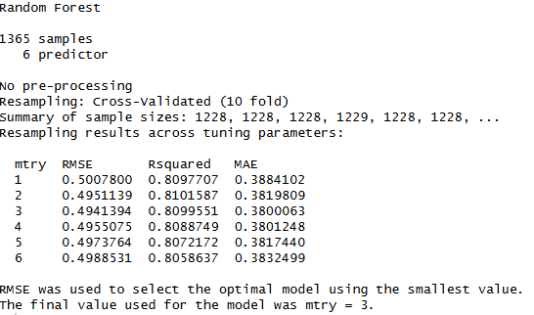

@@@@@@@@@@@@@@@@@@@@@@@@다른 모델 시작@@@@@@@@@@@@@@@@@@@@@@@@@@@@@@@@@@@

Other model!!!!!!
(regression)

### initial setting ###

setwd("D:/998.Python/Data-Analysis-Portfolio/project_06_total_happiness_R")
# data processing
df <- read.csv("data/full_data.csv")
df$year <- as.integer(df$year)
df$country <- as.factor(df$country)
df$region <- as.factor(df$region)
key_vars <- c(
"happiness_score",
"gdp_per_capita",
"social_support",
"healthy_life_expectancy",
"freedom_to_make_life_choices",
"generosity",
"perceptions_of_corruption"
)

# drop out the missing values
df_clean <- na.omit(df)
df_clean$perceptions_of_corruption[df_clean$perceptions_of_corruption == "N/A"] <- NA
df_clean <- df_clean[complete.cases(df_clean), ]
df_clean$perceptions_of_corruption <- as.numeric(df_clean$perceptions_of_corruption)

# 2015~2022: train , 2023 : test
train_data <- df_clean[df_clean$year <= 2022, ]
test_data <- df_clean[df_clean$year == 2023, ]

str(df_clean)

## XGBOOST #####

# xgboost 패키지 설치
install.packages("xgboost")
library(xgboost)

# 데이터 준비
train_matrix <- as.matrix(df_clean[, c("gdp_per_capita", "social_support", "healthy_life_expectancy",
"freedom_to_make_life_choices", "generosity", "perceptions_of_corruption")])
train_labels <- df_clean$happiness_score

# xgboost 모델 훈련
xgb_model <- xgboost(data = train_matrix, label = train_labels, nrounds = 100, objective = "reg:squarederror")

# 예측값 생성
xgb_pred <- predict(xgb_model, as.matrix(test_data[, c("gdp_per_capita", "social_support", "healthy_life_expectancy",
"freedom_to_make_life_choices", "generosity", "perceptions_of_corruption")]))

# RMSE, R^2 계산
xgb_rmse <- sqrt(mean((xgb_pred - test_data$happiness_score)^2))
xgb_rsq <- 1 - sum((xgb_pred - test_data$happiness_score)^2) / sum((mean(test_data$happiness_score) - test_data$happiness_score)^2)

cat("XGBoost RMSE:", xgb_rmse, "\n")
cat("XGBoost R^2:", xgb_rsq, "\n")

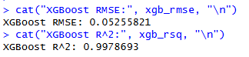

## Linear regrssion ##
# 선형 회귀 모델
lm_model <- lm(happiness_score ~ gdp_per_capita + social_support + healthy_life_expectancy +
freedom_to_make_life_choices + generosity + perceptions_of_corruption,
data = df_clean)

# 예측값 생성
lm_pred <- predict(lm_model, newdata = test_data)

# RMSE, R^2 계산
lm_rmse <- sqrt(mean((lm_pred - test_data$happiness_score)^2))
lm_rsq <- 1 - sum((lm_pred - test_data$happiness_score)^2) / sum((mean(test_data$happiness_score) - test_data$happiness_score)^2)

cat("Linear Regression RMSE:", lm_rmse, "\n")
cat("Linear Regression R^2:", lm_rsq, "\n")
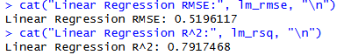

## LightGBM##
# lightgbm 패키지 설치
install.packages("lightgbm")
library(lightgbm)

# 데이터 준비
train_matrix <- as.matrix(df_clean[, c("gdp_per_capita", "social_support", "healthy_life_expectancy",
"freedom_to_make_life_choices", "generosity", "perceptions_of_corruption")])
train_labels <- df_clean$happiness_score

# lightgbm 모델 훈련
lgb_model <- lightgbm(data = train_matrix, label = train_labels, objective = "regression", nrounds = 100)

# 예측값 생성
lgb_pred <- predict(lgb_model, as.matrix(test_data[, c("gdp_per_capita", "social_support", "healthy_life_expectancy",
"freedom_to_make_life_choices", "generosity", "perceptions_of_corruption")]))

# RMSE, R^2 계산
lgb_rmse <- sqrt(mean((lgb_pred - test_data$happiness_score)^2))
lgb_rsq <- 1 - sum((lgb_pred - test_data$happiness_score)^2) / sum((mean(test_data$happiness_score) - test_data$happiness_score)^2)

cat("LightGBM RMSE:", lgb_rmse, "\n")
cat("LightGBM R^2:", lgb_rsq, "\n")

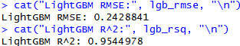

## SVR ###
# e1071 패키지 설치
install.packages("e1071")
library(e1071)

# 지원 벡터 회귀 모델 훈련
svr_model <- svm(happiness_score ~ gdp_per_capita + social_support + healthy_life_expectancy +
freedom_to_make_life_choices + generosity + perceptions_of_corruption,
data = df_clean)

# 예측값 생성
svr_pred <- predict(svr_model, newdata = test_data)

# RMSE, R^2 계산
svr_rmse <- sqrt(mean((svr_pred - test_data$happiness_score)^2))
svr_rsq <- 1 - sum((svr_pred - test_data$happiness_score)^2) / sum((mean(test_data$happiness_score) - test_data$happiness_score)^2)

cat("Support Vector Regression RMSE:", svr_rmse, "\n")
cat("Support Vector Regression R^2:", svr_rsq, "\n")

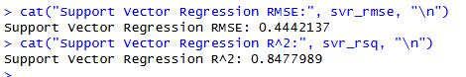

### summary
# 여러 모델의 RMSE와 R² 비교
results <- data.frame(
Model = c("Linear Regression", "XGBoost", "LightGBM", "SVR"),
RMSE = c(lm_rmse, xgb_rmse, lgb_rmse, svr_rmse),
R_squared = c(lm_rsq, xgb_rsq, lgb_rsq, svr_rsq)
)

# 결과 출력
print(results)

